# Name: Oaní da Silva da Costa

Date: 6/3/2018

# Executive summary/abstract:

Since the creation of TCGs (Trading Card Games), players try to use data available to help them win in a complex environment. As you pay a price for your decisions in game, it`s interesting to know if this prices adjusted correctly for what you are paying and what would be the most “efficient deal” in this scenario. Here we made a linear model to access if a minion card’s mana cost in the game Hearthstone can be derived from the cards attributes: Rarity, Set, Attack, Defense and main mechanic. The model revealed different weights according to the factors taken into account and revealed interesting conclusions. The mechanics seem to be balanced with varying weights but without great differences. Cards class show more differences which may mean that balance of creatures varies between classes. Finally, we can conclude from this work that a card generally should never be judged in isolation and that diverse other effects and interactions should be taken into account to balance it as selecting the most efficient mechanics in the most efficient classes is not a guaranteed way to win.

# Introduction:

Games come in diverse kinds and forms in countless media. Usually videogames are associated with action and blood on the screen, but there is an enormous market to games of thought and strategy. Here we will focus in a type of game that has evolved from a tabletop game to a computerized version.

TCGs (trading card games) originally started with magic the gathering in 1993[1]. A In this kind of game players build, out of the match, a deck of cards, as opposed to the conventional 52 card decks and “duel” until one of the two reaches 0 life points through various mechanics. This genre is very flexible with the text in cards being able to create new win conditions. Usually there are “spell” cards and “creature” cards in these games. Creature being cards on the table that attack and defend and spells being temporary effects on the field and players. The name of the genre comes from the fact that the players have to bring a deck build by them outside of the match to play. The cards can be bought and traded.

Since MTG, various card games have been made to dispute this market, for example Yugioh, Pokémon TCG to cite successful ones. There have always been digital versions of these games but until 2014, none of them was too successful. The Yu-gi-oh franchise may have been the most successful on this area as there are various (more than 10) digital adaptations of this game to digital media until 2014.

CCGs is a new version of TCGs that does not contain the trading part, where players “just” collect cards (although not that this is an easy task). It’s supposedly more appealing to the general public as new players can’t be cheated to trade good cards for bad ones, and it may be less computationally complex.

Games before the mass access to internet were developed for offline play like the Gameboy Advance versions of Yugioh or some games of MTG (except MTGOnline of course).

Amongst the CCGs available (a considerable number as 2018) one mark in the history of the genre is the release of Hearthstone (HS)

In 2014, Hearthstone was released and it revolutionized the market. Differently from other digital CCGs, it was an experiment from blizzard to make a cheaper game but deep and fun like more costly ones like StarCraft. As the indie scene grew, they tried to make one themselves and were very successful[2].

Hearthstone is a CCG about the Warcraft universe. It’s designed to be simple to play yet complicated to master, a common design principle today where it can cut costs and maximize profits, supposedly having appeal to any public, casual or the called hardcore ones (professionals and people who invest money to win).

The games mechanics are indeed simple. Each player starts with 30 life points. There are creatures, spells and weapons. In short, each of them do damage, recover life or make interactions.

## Mechanics

The game is a virtual board game where players spend resources (mana) to play cards on the field. These cards have various features, all supposed to be correlated to the mana cost, where stronger cards (in the sense that they “beat” weaker ones) have a higher mana cost.

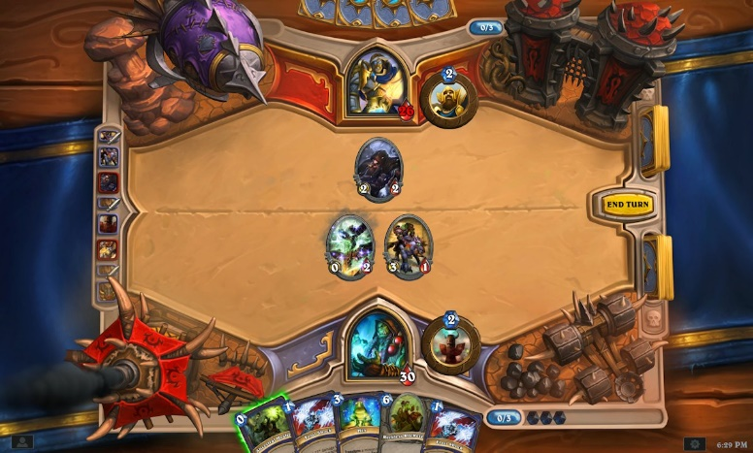

Picture 1: The game board (From <http://hearthstone.wikia.com/wiki/Game_boards>)

Picture 1 shows a typical Hearthstone game. The board allows 7 minions on each side and 10 card on the player’s “hands”. A hero power mechanic exist but will not be addressed to this work.

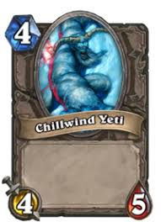

Picture 2: A “simple” minion card (from <https://hearthstone.gamepedia.com/Chillwind_Yeti>)

In Picture 2, we can see a typical minion card.

The blue crystal at the top is the card’s cost. You get one mana to spend per turn so turn 1: 1 mana, turn 2: 2 mana and so on until turn 10, the maximum quantity.

The yellow sword at the bottom represents the card’s attack. The red blood represent its health points. Attack subtracts life points to a minion. If it reaches 0 points, it is destroyed.

This kind of minion, with no text, used to be more common at the first set of card released, giving place today to more complex mechanics. Note that the mana cost seems to be proportional to the common attributes of minion cards, attack and health.

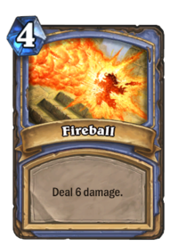

Picture 3: A “simple” spell card (from <https://hearthstone.gamepedia.com/Fireball>)

Picture 3 shows a simple spell card from a class. We can say that it simply converts mana to damage. After played the card is lost.

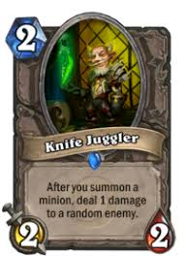

Picture 4: A more complex minion card (from <https://hearthstone.gamepedia.com/Knife_Juggler>)

This minion however is much more complex than the one from Picture 2. It’s text depend on other factors happening on the field but it’s core mechanic involver dealing damage, besides being able to attack.

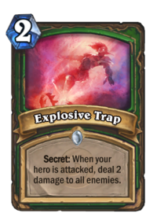

Picture 5: A more complex spell card (from <https://hearthstone.gamepedia.com/Explosive_Trap>)

This one is a much more complex spell than the one from picture 3. Its text takes into consideration events in the playing field while it deals damage too. Note that it is a more complex spell card, a secret. Secrets “trigger” when its events happen.

## Additional mechanics

There are additional mechanics that affect a card’s cost that are not in the card but arise from the state the game is in.

As Wikipedia (<https://en.wikipedia.org/wiki/Metagaming>) defines:

“Metagaming is any strategy, action or method used in a [game](https://en.wikipedia.org/wiki/Game) which transcends a prescribed ruleset, uses external factors to affect the game, or goes beyond the supposed limits or environment set by the game. Another definition refers to the game universe outside of the game itself.”

Players play the game as a community. There are relations between cards that make some cards advantageous over others depending on certain conditions. For example, let’s imagine a 3 mana 1/1 creature that has battlecry: destroy all murlocs.

This card is conditional on the presence of murlocs in the field. If currently are many murlocs in the so metagame than players are rewarded for choosing this card. If there are not, the opposite happens, as they will have a “dead card” in their decks.

Supposedly, to keep the spending on new cards interesting these cards should be slightly better than previous ones. This effect of slow but incremental “power” of the cards is called power creep and has been observed in diverse card games. Therefore, supposedly, there should be time correlations between the cards too. Newer ones being stronger.

As a result of these effects cards are constantly being balanced, either by the banning of powerful cards or remaking them (for example, a 5 mana 4/4 that have so many interactions that in practice is always a 5 mana 6/6 can be “nerfed” (made worse) to be a 6 mana 4/4.

One of the most powerful “unwritten” mechanics in TCGs takes in account the fact that the game is divided into thirds.

Ex: if I play 1/1 creature in turn.

My opponent play the same creature in her turn

My turn 2: I destroy my opponent’s creature with a spell and damage her life points for 1.

It is said that I have took advantage of tempo.

This is a serious issue in Hearthstone since attackers can choose targets. This “hidden mechanic” is so present in this game that cards sometimes are nerfed just so people play them later.

Beying a so complex game, it is interesting to maximize the effect of the cards of your deck. To help reach this objective, It’s supposedly useful to check if a card’s mana cost is under of over its supposedly “balanced” value in a manner similar to what Elie Bursztein says in his blog[3] so you can decide by seeing a card if it’s worth it’s cost.

It should be noted here that the cost of a card is by no means directly proportional to the cards attributes. As said before cards interact with each other having various correlations. However, they are selected independently to compose a deck and sometimes have to be played alone. It`s still worthwhile to search what individual attributes most “cost” you when you play them.

## Objective:

Explore the relation between a cards mana cost and its mechanics. To do this a linear model will be build which cost being explained by other variables that compose a card. Different from Elie Burstein’s work here we checked if the mere presence of a mechanic in a card (deal damage, draw card, *et c*.) impacts its mana cost and how much. This is primarily an exploratory work. As noted above the cards correlate to much with each other and a simple linear modeling will never reveal a card’s true mana cost.

# Data:

The data come from a json file from the website <https://hearthstonejson.com/docs/cards.html> that contains data on all the cards released until today (6/1/18). This data was chosen for the satisfactory amount of cards it addresses. A large dataset will help to make useful conclusions. It is publicly available and free to use. To treat the data the libraries rjags, rjson, coda and jsonlite were used. The database contains 1614 observations (cards) and 33 variables.

# Model:

As cards are supposedly balanced (at least initially) based on its constituent attributes it`s interesting to check if this relation is linear and mana price can be derived from the cards values. A hierarquical model was chosen as to access if there are correlations among cards in some attributes like set of rarity. We choose uninformative priors as there are various variables and a substantial amount of observations making the data drive the results almost entirely.

Convergence was OK but correlation in the data was a problem. Even increasing the number of iterations did not seem so solve the problem.

Predictive performance does not seem good. Specific cards cannot be derived from this model, but this was expected, as some observations are clear outliers and should affect the results. Still the comparisons between the weights are valuable.

The model is described below:

$$y_{i} | p_{mibirici}, ω_{pmibirici},σ \sim ^{ind} N\left(ω_{mibirici}, σ\right)$$

$$ω_{pmibirici}= c_{i}+ b_{1}*attack + b_{2}*health + b_{3}*race + r_{i}*rarity + m_{i}*mechanics \\ m_{i} ϵ \left(list of mechanics\right) \sim N(α, σ) \\ r_{i} ϵ (list of rarities) \sim N(α, σ) \\ c_{i}ϵ (list of card classes) \sim N(α, σ) \\ α \sim N(0.0, 1.0/1.0e6) \\ σ \sim G(2, 0.2)$$

# Results and Conclusions:

| Factor | Multiplyer | Mean | SD | Naïve SE | Time-series SE |
| --- | --- | --- | --- | --- | --- |
|  | a0 | 0.084295 | 0.07891 | 2.04E-04 | 4.35E-04 |
| attack | b[1] | 0.448522 | 0.02442 | 6.30E-05 | 2.02E-04 |
| health | b[2] | 0.41022 | 0.02187 | 5.65E-05 | 1.90E-04 |
| race (yes or no) | b[3] | 0.03037 | 0.01872 | 4.83E-05 | 2.36E-04 |
| DRUID | c[1] | 0.567922 | 0.23575 | 6.09E-04 | 2.95E-03 |
| HUNTER | c[2] | 0.229165 | 0.23442 | 6.05E-04 | 3.24E-03 |
| MAGE | c[3] | 0.021578 | 0.23821 | 6.15E-04 | 2.93E-03 |
| NEUTRAL | c[4] | 0.278831 | 0.18838 | 4.86E-04 | 3.20E-03 |
| PALADIN | c[5] | 0.239214 | 0.24168 | 6.24E-04 | 2.87E-03 |
| PRIEST | c[6] | 0.043021 | 0.23514 | 6.07E-04 | 2.87E-03 |
| ROGUE | c[7] | 0.089925 | 0.23559 | 6.08E-04 | 2.90E-03 |
| SHAMAN | c[8] | 0.154219 | 0.23909 | 6.17E-04 | 2.93E-03 |
| WARLOCK | c[9] | 0.027902 | 0.22827 | 5.89E-04 | 3.04E-03 |
| WARRIOR | c[10] | 0.139671 | 0.23776 | 6.14E-04 | 2.89E-03 |
| ADJACENT_BUFF | m[1] | 1.341753 | 0.50982 | 1.32E-03 | 1.98E-03 |
| AURA | m[2] | -0.1491 | 0.21048 | 5.44E-04 | 6.59E-03 |
| BATTLECRY | m[3] | -0.12525 | 0.12849 | 3.32E-04 | 4.56E-03 |
| CANT_ATTACK | m[4] | 0.206315 | 0.17638 | 4.55E-04 | 2.98E-03 |
| CANT_BE_TARGETED_BY_HERO_POWERS | m[5] | 0.12632 | 0.14319 | 3.70E-04 | 2.46E-03 |
| CANT_BE_TARGETED_BY_SPELLS | m[6] | -0.03243 | 0.12112 | 3.13E-04 | 2.04E-03 |
| CHARGE | m[7] | -0.0663 | 0.06938 | 1.79E-04 | 1.88E-03 |
| CHOOSE_ONE | m[8] | -0.07325 | 0.06329 | 1.63E-04 | 1.64E-03 |
| COLLECTIONMANAGER_FILTER_MANA_EVEN | m[9] | -0.03918 | 0.14362 | 3.71E-04 | 1.28E-03 |
| COLLECTIONMANAGER_FILTER_MANA_ODD | m[10] | -0.09261 | 0.12968 | 3.35E-04 | 1.18E-03 |
| COMBO | m[11] | -0.07025 | 0.04809 | 1.24E-04 | 1.20E-03 |
| DEATH_KNIGHT | m[12] | 0.029038 | 0.10884 | 2.81E-04 | 9.97E-04 |
| DEATHRATTLE | m[13] | -0.03111 | 0.03064 | 7.91E-05 | 1.05E-03 |
| DIVINE_SHIELD | m[14] | 0.004615 | 0.03298 | 8.52E-05 | 9.63E-04 |
| ECHO | m[15] | -0.04382 | 0.04269 | 1.10E-04 | 8.84E-04 |
| ENRAGED | m[16] | -0.00923 | 0.0346 | 8.93E-05 | 8.36E-04 |
| FINISH_ATTACK_SPELL_ON_DAMAGE | m[17] | 0.04073 | 0.07729 | 2.00E-04 | 7.26E-04 |
| FORGETFUL | m[18] | -0.00614 | 0.04116 | 1.06E-04 | 7.20E-04 |
| FREEZE | m[19] | 0.003832 | 0.03901 | 1.01E-04 | 6.58E-04 |
| GRIMY_GOONS | m[20] | -0.04447 | 0.04134 | 1.07E-04 | 6.32E-04 |
| HEROPOWER_DAMAGE | m[21] | -0.05406 | 0.06321 | 1.63E-04 | 5.90E-04 |
| INSPIRE | m[22] | -0.02164 | 0.02151 | 5.55E-05 | 6.00E-04 |
| InvisibleDeathrattle | m[23] | -0.02345 | 0.05762 | 1.49E-04 | 5.32E-04 |
| JADE_GOLEM | m[24] | 0.011097 | 0.04083 | 1.05E-04 | 5.30E-04 |
| JADE_LOTUS | m[25] | -0.02258 | 0.03308 | 8.54E-05 | 5.08E-04 |
| KABAL | m[26] | -0.05266 | 0.03184 | 8.22E-05 | 5.00E-04 |
| LIFESTEAL | m[27] | -0.02618 | 0.01951 | 5.04E-05 | 4.91E-04 |
| OVERLOAD | m[28] | -0.00888 | 0.01979 | 5.11E-05 | 4.67E-04 |
| POISONOUS | m[29] | -0.00836 | 0.02032 | 5.25E-05 | 4.50E-04 |
| RITUAL | m[30] | -0.01042 | 0.01631 | 4.21E-05 | 4.47E-04 |
| RUSH | m[31] | -0.00183 | 0.01673 | 4.32E-05 | 4.28E-04 |
| SPELLPOWER | m[32] | -0.00928 | 0.01506 | 3.89E-05 | 4.15E-04 |
| START_OF_GAME | m[33] | -0.02154 | 0.02508 | 6.48E-05 | 3.95E-04 |
| STEALTH | m[34] | -0.00414 | 0.01388 | 3.58E-05 | 3.96E-04 |
| TAUNT | m[35] | -0.01173 | 0.01153 | 2.98E-05 | 3.91E-04 |
| TOPDECK | m[36] | -0.03078 | 0.02703 | 6.98E-05 | 3.52E-04 |
| TRIGGER_VISUAL | m[37] | -0.00904 | 0.01057 | 2.73E-05 | 3.66E-04 |
| WINDFURY | m[38] | 0.000906 | 0.01456 | 3.76E-05 | 3.48E-04 |
| COMMON | r[1] | 0.57085 | 0.36807 | 9.50E-04 | 1.27E-02 |
| EPIC | r[2] | 0.679812 | 0.1904 | 4.92E-04 | 6.35E-03 |
| FREE | r[3] | 0.235602 | 0.1342 | 3.47E-04 | 4.19E-03 |
| LEGENDARY | r[4] | 0.380262 | 0.09628 | 2.49E-04 | 3.17E-03 |
| RARE | r[5] | 0.148674 | 0.07517 | 1.94E-04 | 2.56E-03 |
|  | sig | 1.266355 | 0.02778 | 7.17E-05 | 8.27E-05 |
|  | tau | 0.5262 | 0.06174 | 1.59E-04 | 5.82E-04 |

Picture 6: Comparison of weights

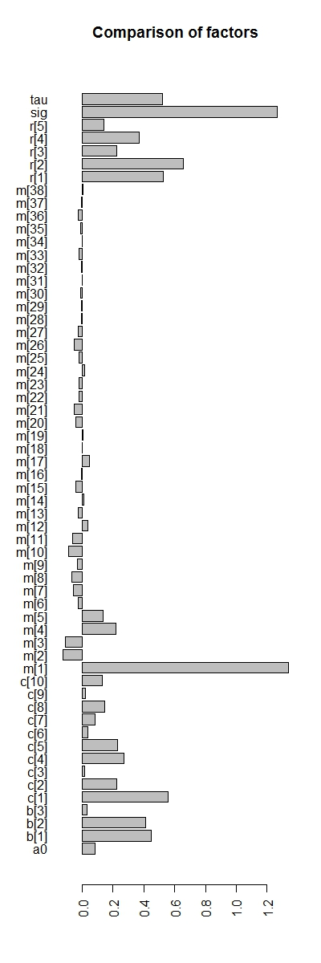

In Picture 6, we can compare what factor most impacts a card cost.

It is clear the relation of attack and defense, a card should have a little more health than attack to cost for its attack, which explains the minion in picture 2.

Interestingly there seems to be different weights by class. This maybe happened as classes have different number of creatures and values for them because of balancing issues. Therefore, these weights maybe reveal more about the classes than model the cards.

Another interesting conclusion is the similar magnitude of the weights of the mechanics. The model here ignores the various complexities of these mechanics. For example spell power is always accompanied by a multiplier (e.g. “spellpower +1” or “spellpower +5”) wich were never taken into account here. Therefore, the mere presence of a mechanic in a card does not tell us much about it. This seems uninformative but if it was otherwise the game would suffer from a balancing issue, or, playing a “battlecry” deck, or a “deathrattle” deck would by itself be advantageous, which is not.

Another interesting result is the relation of rarity and mana cost. Clearly, rarity plays a role on a card’s cost. This has never been a secret as more rare cards have more complex mechanics, which makes the cards less and less “linear”. Take the card from picture 7 for example.

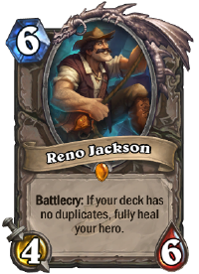

Picture 7: Reno Jackson minion (from https://hearthstone.gamepedia.com/Reno_Jackson)

This card cannot be treated as an outlier because various legendary cards are like this and this rarity may have less copies of itself in a deck. A more complex model should be build do address these issues but the mere fact that rarity plays a role should lead to the following conclusion: Legendary cards are “nonlinear”, not stronger. This VAI CONTRA a simple yet deceiving notion that players that simply put a legendary card in a deck make it stronger. Evidence here leads us to conclude that yes, if the nonlinearity present in it does this job, a card alone should not make the deck stronger.

Finally, we can conclude that each part of the card indeed have a value to contribute to the mana cost and they differ greatly sometimes. These values may change over time due to power creep and balancing

Yet mana efficiency shouldn’t tell us too much about the outcome of a game as it`s the direct result of comparison of cards and doesn’t account for correlations.

Here we tried to evaluate what makes a card cost what it cost. The conclusion reached was that merely maximizing the effectiveness of the card’s mana cost is not a guaranteed way to win every match.

1. <https://en.wikipedia.org/wiki/Collectible_card_game#History_of_the_Collectible_Card_Game>
2. [https://en.wikipedia.org/wiki/Hearthstone#Development](https://en.wikipedia.org/wiki/Hearthstone" \l "Development)
3. <https://elie.net/blog/hearthstone/how-to-appraise-hearthstone-card-values>